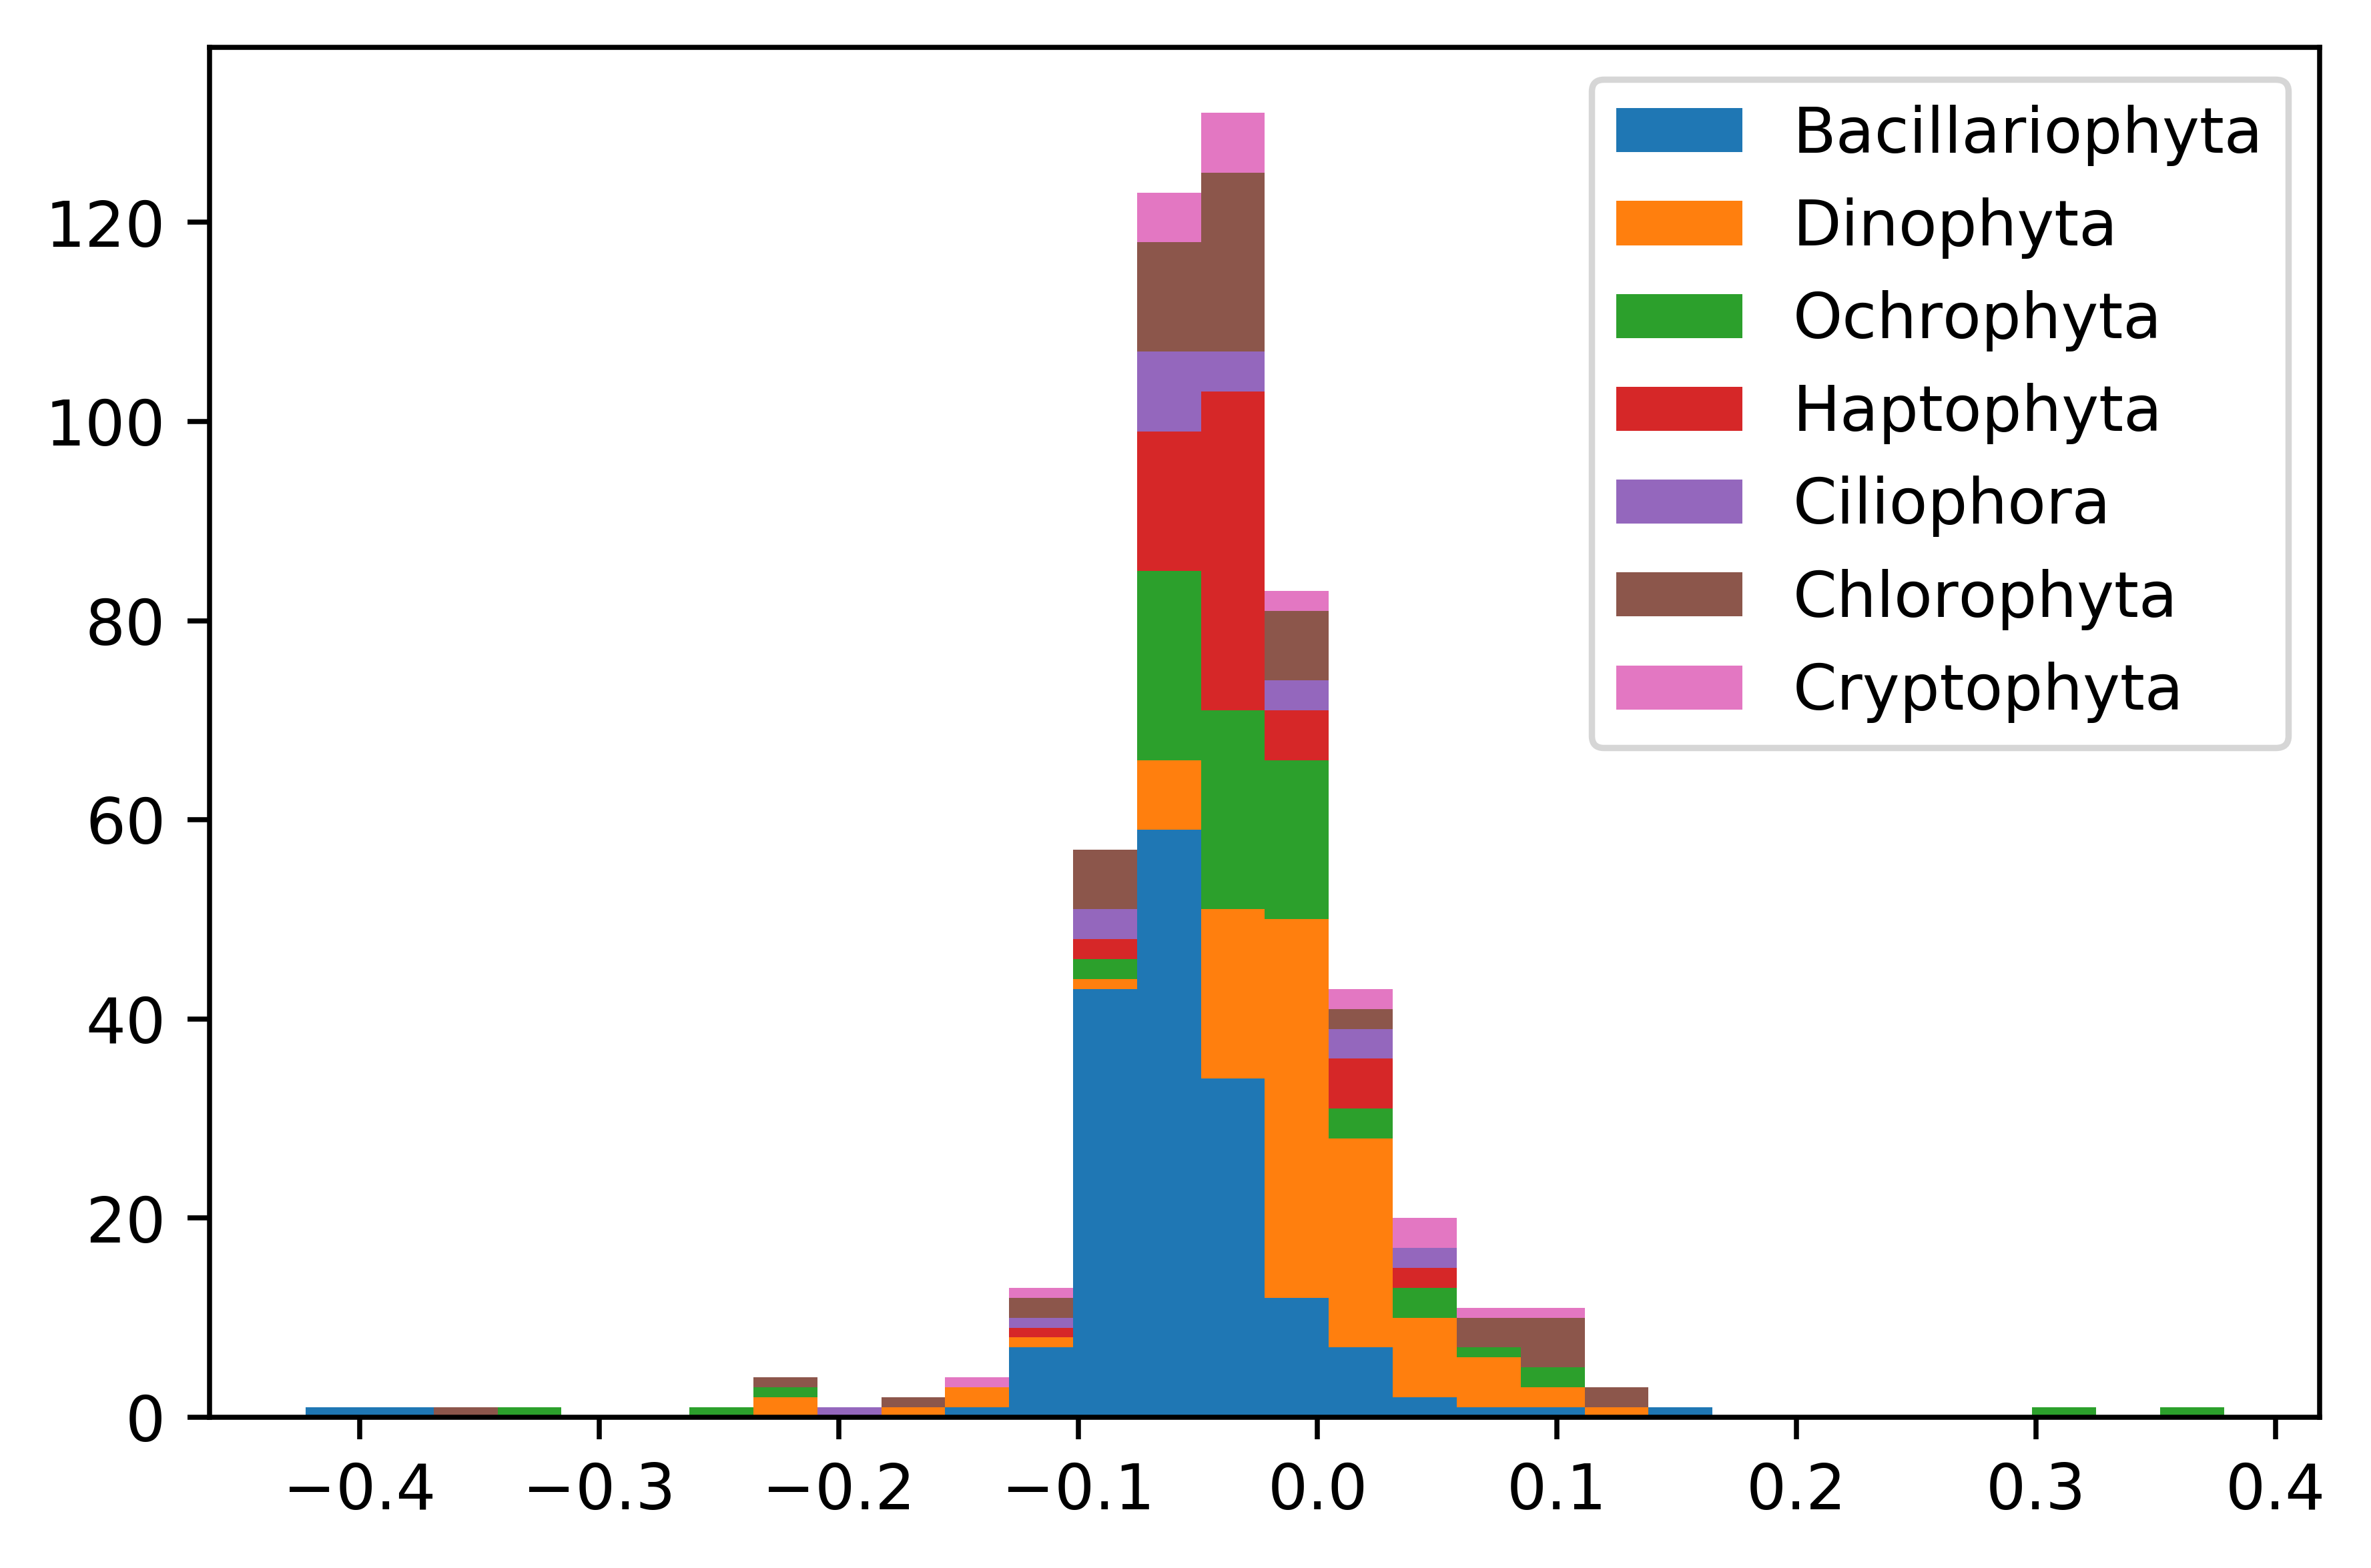

Supplemental Figure 2. There do not appear to be taxonomic trends in the frequency of differences between Transrate scores in the NCGR ‘nt’ assemblies and the DIB re-assemblies. Negative values indicate Transrate scores from NCGR assemblies were higher and positive values indicate scores from DIB re-assemblies were higher.